
THE NATIONAL INSTITUTE OF ENGINEERING
MYSURU-570008

DEPARTMENT OF ELECTRONICS AND COMMUNICATION ENGINEERING



ANALOG CMOS IC-1 LAB PROJECT [EC3L01] –III Semester
REPORT ON
MOTOR DRIVER USING MOSFET

Under the guidance of:
Deepthi M S
Asst. Professor, Department of ECE

Submitted By:
Prajwal S D : 4NI18EC052
Suraj U Mogali : 4NI18EC093
Veerendra S Maradur : 4NI18EC105

2019-20
ABSTRACT

DC motors form the backbone of many industries and as such their speed control becomes of immense importance. It has been found that many of these applications perform with a greater efficiency when the motors are fed from a source of variable dc power. In this report we analyze the separately excited dc motor using MOSFET for speeds above and below the rated speed using a chopper circuit. The chopper circuit receives a signal from the firing circuit and then gives a signal to the armature voltage controller of the separately excited dc motor and the speed is accordingly increased or decreased. In this system we use two different control loops, in for speed and another for current. Here we use a proportional integral type control as in this the delay gets removed and the control provided is very fast.
TABLE OF CONTENTS

- INTRODUCTION
- DESIGN AND IMPLEMENTATION
- TESTING/ RESULT AND ANALYSIS
- CONCLUSIONS
- REFERENCES

Introduction

Industries are the backbone of the modern era and so it is of utmost
importance that they always run with the highest possible efficiency.
And for this reason many industrial applications require dc voltage
sources, some by force and some by choice. However many of them
perform better when they are fed from a variable dc source as
compared to fixed voltage sources. These include battery operated
vehicles, subway cars, battery charging etc. The conversion of fixed dc
voltage to variable dc can be obtained by using semiconductor
devices. Earlier this used to be achieved by AC link motor but was
costly, bulky and less efficient. This is the place where the dc chopper
comes into play. Being a single stage conversion device the dc motor
has altogether heralded a new era in rapid transit systems. As most of
the traction systems in India still operate via dc motors this project
aims to simulate and analyze a model of dc motor using
MOSFET and study the speed control characteristics and the
advantages and limitations of using a MOSFET.

DESIGN AND IMPLEMENTATION

Components Required:
1. N-channel MOSFET
2. A 6v dc motor
3. A 9v battery
4. Single stand wires
5. Breadboard
6. A small fan
7. A 10K pot

MOSFET:
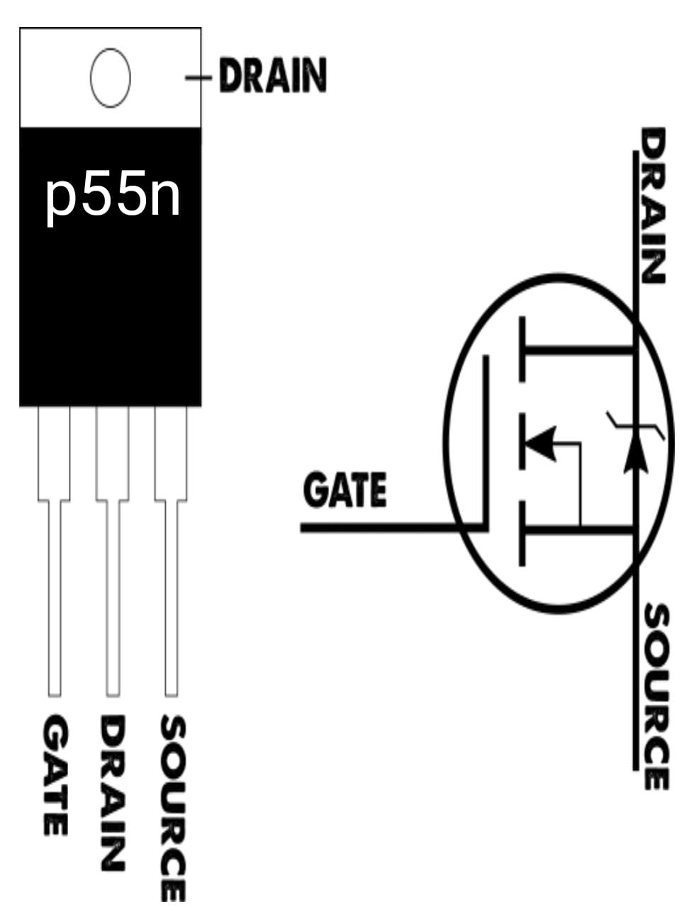

MOSFET is a voltage controlled device and has zero storage time. MOSFET is highly suitable for high frequency switching and as such is widely used because of absence of minority carrier storage time.

DC Motor:

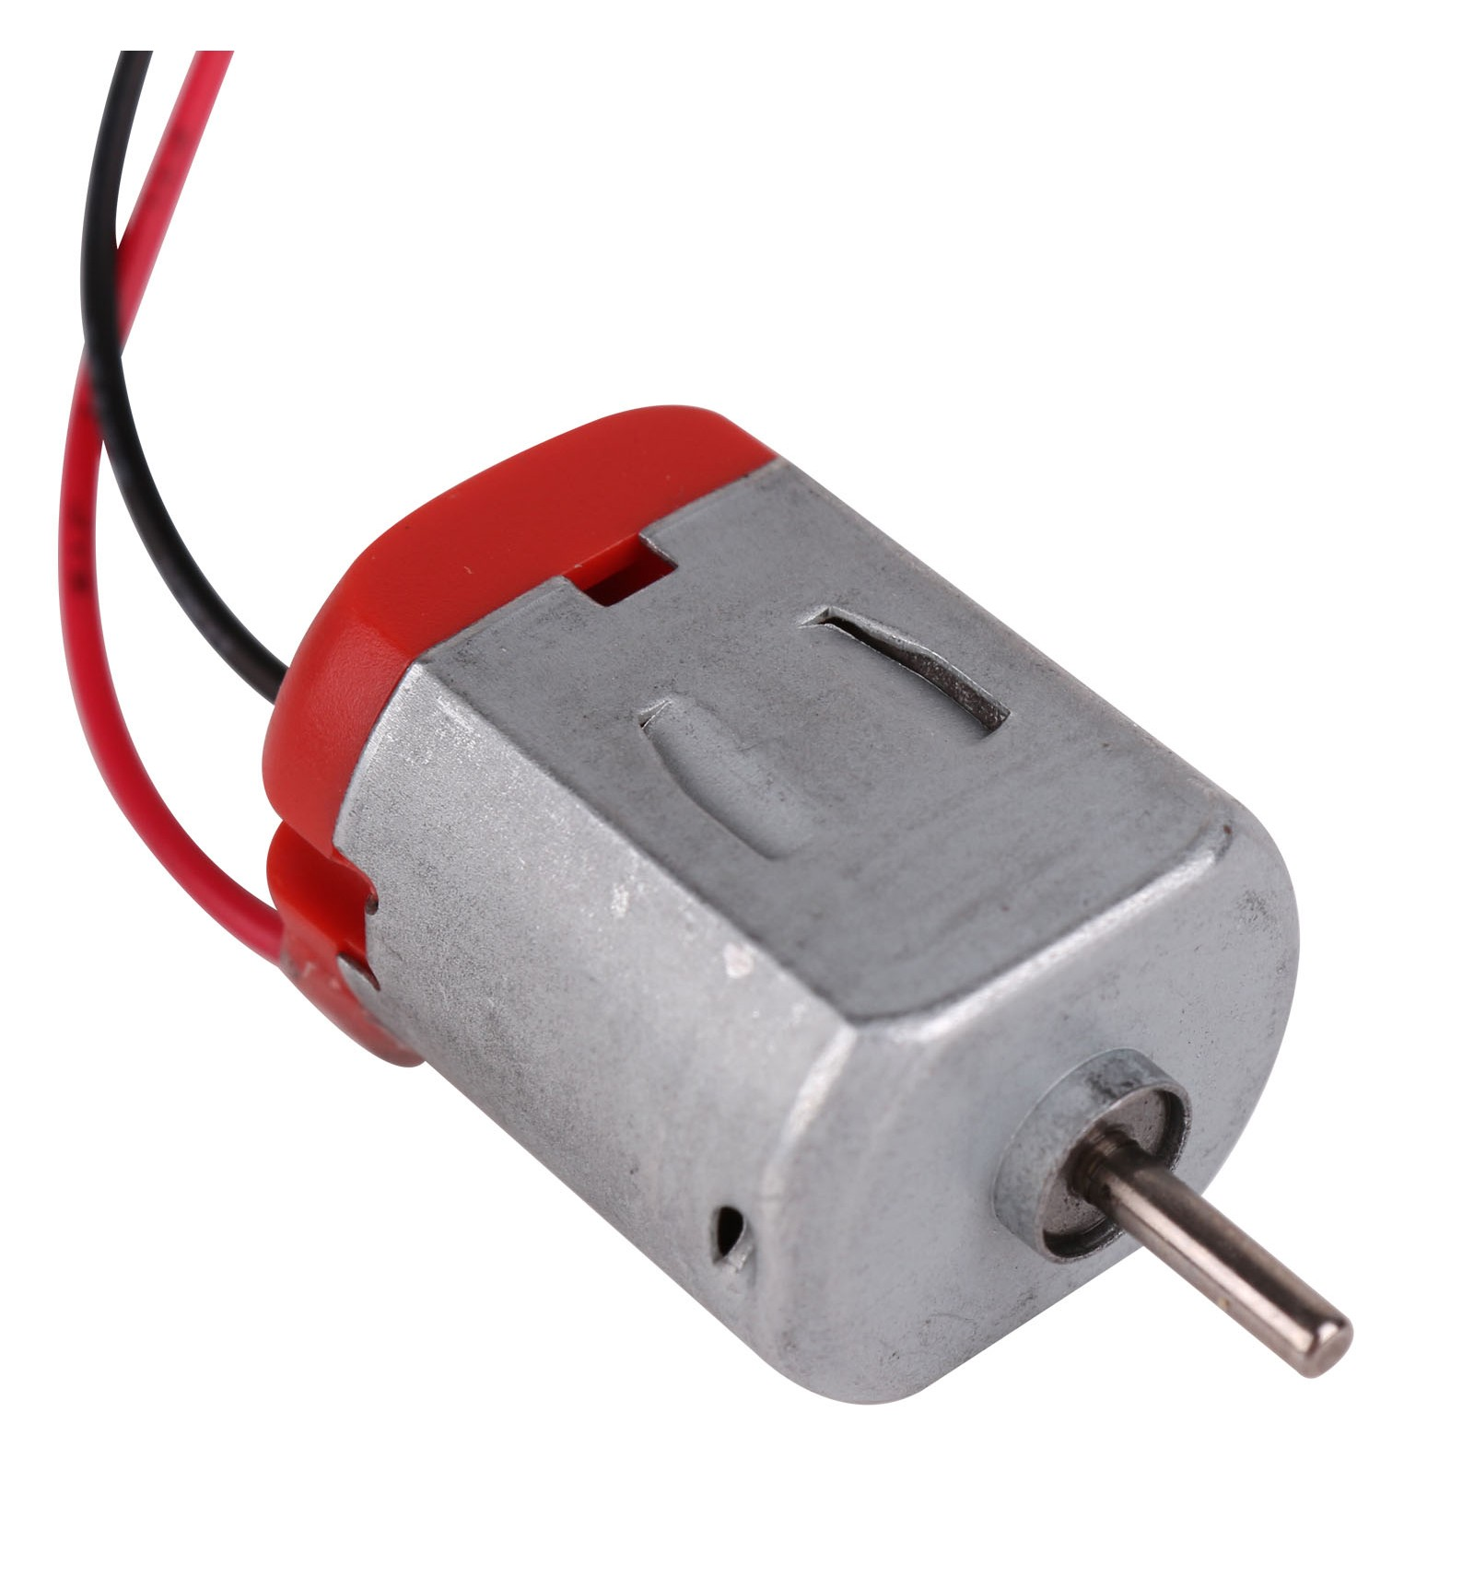
In a separately excited dc motor the armature winding and the field winding is supplied from two different sources. The current flows in the field winding and produces the flux which in turn interacts with the armature current and results in the formation of the torque.

Working:
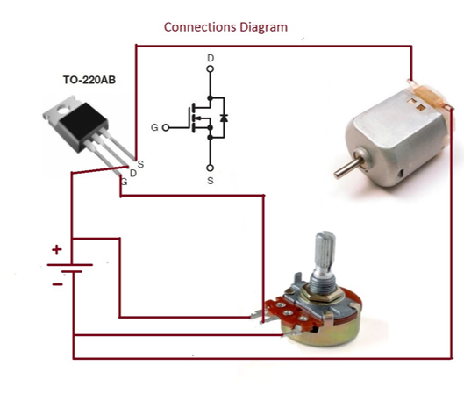
Rotating the knob controls the speed of the motor. Positive is connected to D of the MOSFET. The MOSFET should be a N channel Enhancement MOSFET (IRF540, IRF3205,). Do not short the connections of the power supply. It may lead to damage to power supply and fire/explosion in case of a battery. The supply voltage depends on MOSFET and the motor. Example: If thesis sis designed for 12v and MOSFET is capable of 50v.The supply voltage should be 12v.

RESULT AND ANALYSIS

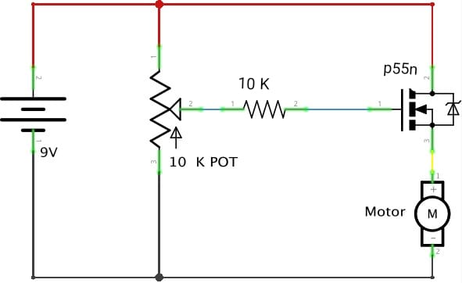

The MOSFET is configured as a source follower. The output voltage is gate voltage minus threshold voltage. The variable resistor (Potentiometer, “POT") controls the voltage at the gate. The voltage at gate with reference to source(Vgs) determines the current flow through the motor. When the Vgs reaches around 2v the channels starts to open, as we keep increasing Vgs,the channel becomes wider allowing greater current to flow.

As we apply the voltage to the gate, the current flows from the drain to source opposite to the direction of electrons. Varying the resistance in the pot, the voltage in the mosfet changes, depending on the voltage applied the speed of the motor changes. As ohm’s law states V=IR, if resistance is increased, voltage increases.

CONCLUSIONS:
Here we see that the speed of a dc motor can be successfully controlled by employing a motor circuit. Here we initially study the basic output characteristics of a MOSFET based motor and study the output variables for various load characteristics and then study it for various change in load torque, rated voltage value and other input parameters. The loops involved can be carefully optimized using various mathematical approaches and finally the circuit is simulated and the various plots obtained under various conditions are carefully studied.

FUTURE SCOPE:
The above described model has been run and tested successfully in MATLAB simulation, so there lies the opportunity to implement the above described model in hardware and study the impact of the approach taken in this thesis report. Moreover in this report we have analyzed only the impact of the approach on separately excited dc motor so there lies the scope to extend the study to various other kinds of motors. Also here we have done the speed control below the rated speed so analysis can also be extended to study the dynamics for above the rated speed

References:
This project consists of all the information and the components required. For further information visit the link mentioned below
https://www.youtube.com/watch?v=dpNhtna-iv8&t=129s
https://www.instructables.com/id/DIY-MOSFET-Motor-Controller/

